Vehicle-to-Home Energy Management: A Simulation Tool for Assessing Flexibility, Savings and Self-Sufficiency

Cécilia Lebarbey, Tim Marentič
University of Ljubljana, Faculty of Electrical Engineering
Tržaška cesta 25, 1000 Ljubljana, Slovenia
Email: cecilia.lebarbey@groupe-esigelec Tim.Marentic@fe.uni-lj.si

Abstract:

Introduction
The increasing share of renewable energy in power systems calls for greater flexibility. At the same time, electric vehicles (EVs) are emerging as a growing but underused source of distributed energy storage. As transportation becomes increasingly electrified, the correlation between traffic patterns and electricity demand is also intensifying, revealing new interactions between the energy and mobility sectors.
Among Vehicle-to-X (V2X) solutions, Vehicle-to-Home (V2H) stands out as a promising approach. It enables direct energy exchange between an EV and a household, with potential benefits such as improved self-consumption of solar energy, lower electricity bills, and reduced stress on the electrical grid.
Despite this potential, very few tools exist to simulate realistic V2H scenarios in a simple, customizable, and accessible way. This project aims to develop an intuitive simulation tool that fills this gap. The tool supports cross-country comparisons, seasonal variation, and different user profiles, and is designed for both educational and exploratory use. This article presents the simulation tool, explains how it was built, explores a range of scenario-based tests, highlights one illustrative case study, and shares user feedback from hands-on testing.

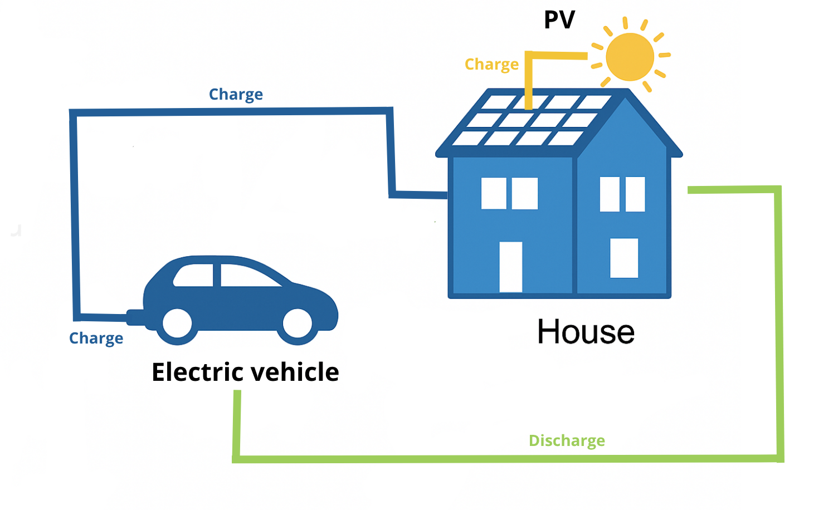

Figure 1. Energy flow diagram of a residential Vehicle-to-Home (V2H) system.

Simulation tool and Methodology

Simulation tool
We developed a Python simulator for 24-hour, hourly-step modeling of energy exchanges in a V2H system. Interacting entities include household demand, PV generation, EV battery, and the grid. The rule-based logic prioritizes self-consumption: PV serves the house first, the EV discharges to meet any remaining demand, and surplus PV or off-peak grid energy is used to charge the EV. Constraints include a maximum power of 11 kW, a minimum SoC of 20 %, a target SoC at departure, and scenario-specific connection windows. Outputs include hourly SoC, energy flows, and performance KPIs (autonomy, savings, flexibility). An overview of the tool structure and interface is shown in Figure 2

Figure 2. Overview of the simulation tool and user interface.

Input data
Hourly PV outputs are based on PVGIS data (20.5 % efficiency), scaled per city (9–15 kWp). Household demand follows five behavioral profiles (e.g., Morning Glory). EV models span 40–80 kWh capacities with 11 kW bidirectional capability, factoring in SoC limits and connection schedules. Dynamic, city-specific tariffs (off-/mid-/peak) guide charging and discharging priorities.

Test case design
Five realistic use cases (UC1–UC5) explore variations in connection timing, SoC targets, and user behavior—from a weekday home worker (UC1) to weekend and fleet scenarios. These cases test the influence of context on energy performance, flexibility, and economic value.

KPIs
Key metrics include energy charged/discharged (kWh), EV and PV contribution to household demand, available flexibility, local self-sufficiency (%), and cost savings (€) compared to a grid-only baseline. These indicators reflect both technical performance and financial impact.

Results: Case study, size of the battery

To assess the role of battery capacity in V2H performance, we compared two vehicle configurations under the same scenario: a summer day in Paris, with connection from 19:00 to 11:00, an initial state of charge (SoC) of 50 %, and a target of 90 %. All other parameters were kept constant, including the solar installation (9 kWp), household profile (UC2), and dynamic tariff structure.
The two EVs differed only in their battery capacity: a small car with 40 kWh (Renault Zoé) and a large car with 80 kWh (BMW iX3). Despite the larger energy throughput of the BMW (38.9 kWh charged, compared to 22.9 kWh), key performance indicators remained nearly identical between the two cases. Both vehicles discharged 6.9 kWh to support the home, reached the same flexibility level (45.4 %), and had equal PV contribution during the connection window (24.11 kWh), of which 19.21 % directly supported household needs. The self-sufficiency rate was 86.3 % in both cases.
Interestingly, the small battery configuration yielded slightly higher cost savings (0.92 € vs. 0.88 €), due to lower grid dependency. These results highlight that, under short connection windows and limited PV availability, larger battery capacities offer little additional value. In such contexts, charging needs dominate the energy strategy, leaving little room for discharge optimization or surplus storage. Battery oversizing may thus lead to underused flexibility unless paired with longer connection periods or more abundant solar production.
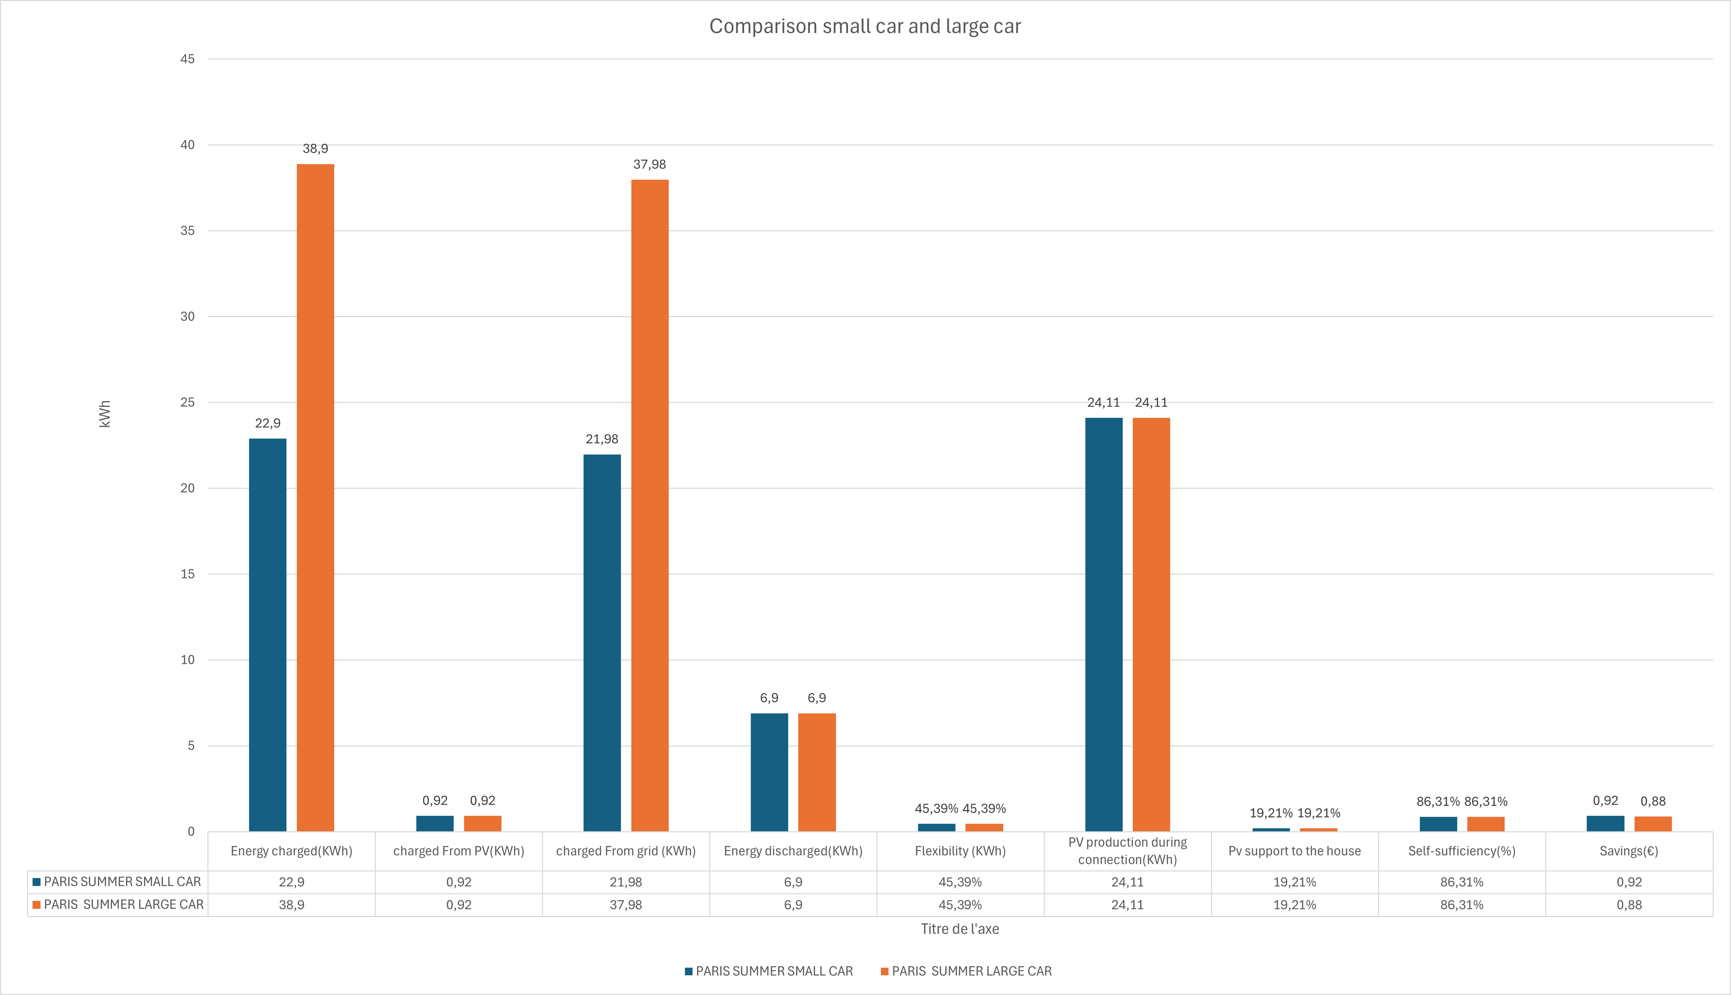
Figure 4. Impact of battery size on performance indicators for the same scenario (Paris, summer weekday).

Results: Internal testing by domain experts

Conclusion

References
[1] PVGIS. “Photovoltaic Geographical Information System.” European Commission, 2024. [Online]. Available: https://joint-research-centre.ec.europa.eu/pvgis_en
[2] M. Marentič, et al. “Electric Vehicle Flexibility in Future Grids.” IEEE Trans. Smart Grid, 2022.
[3] A. Lopez, et al. “Modelling User Behavior for V2X Applications.” Energies, vol. 15, no. 7, 2023.
[4] L. Striani, et al. “Optimal Scheduling of EVs with Time-of-Use Tariffs.” Appl. Energy, 2021.

